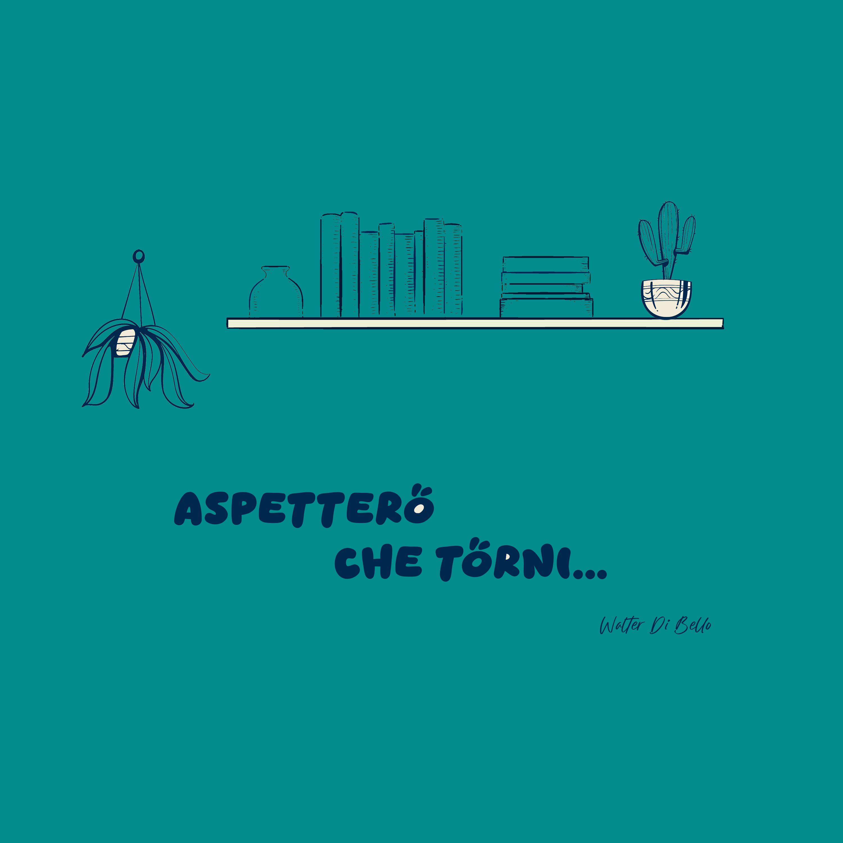

Walter Di Bello
announces his first Italian single
Aspetterò che torni

After years of releasing music in English, singer-songwriter and musician Walter Di Bello is entering a new phase of
his artistic journey with his first Italian-language single, "Aspetterò che torni". The song, released under La Rue
Music Records, a label with which he continues his collaboration after the 2023 album No Genre, marks a natural
evolution of his musical style, blending folk and pop with the depth and richness of the Italian language.

A journey through emotion and reflection

A
spetterò che torni" is an intense and captivating ballad that explores the theme of longing and waiting for a loved
one. The song highlights the importance of every nuance of a relationship, from its joys to its challenges, as
reflected in the lyrics "A schernire i miei passi, i miei gesti, come sai fare tu" ("Mocking my steps, my gestures,
as only you can"). Through this phrase, Walter reflects on the value of those who help us see our own flaws with
lightness and irony, making love a journey of growth and self-awareness.

Exceptional musicians for a refined arrangement

For the creation of the track, Walter Di Bello collaborated with talented musicians who helped give the song an authentic personality.

Walter Di Bello – Vocals, guitar, lyrics, and melody composition
Antimo Aiezza – Drums
Pietro Lorenzotti – Bass
Gianmarco Capece – Piano

The recording process embraced spontaneity, allowing the musicians to express themselves freely, adding details and nuances that enrich the song. The result is an evocative sound that transports the listener into the heart of the music.

A top-tier production team

The mixing was handled by Edoardo Di Vietri from Hexagon Lab Recording Studio in Vallo della Lucania, a longtime collaborator of Walter, known for shaping a well-defined and recognizable sonic identity.
For mastering, Walter entrusted Tommy Bianchi, one of Italy’s most renowned sound engineers, known for working with artists such as Elio e le Storie Tese, Patty Pravo, Marlene Kuntz, Trio Bobo, Paolo Benvegnù, and Francesco Di Giacomo. His expertise has given the song an impeccable sound, making it perfectly suited for radio airplay.

A new album on the horizon

The release of "Aspetterò che torni" marks the first step towards a new album, which will gradually be enriched with more singles. The album will feature both Italian and English songs, along with special collaborations that will be revealed in the coming months.

